FEDERATION CYNOLOGIQUE INTERNATIONALE (AISBL)
13, Place Albert 1er, B - 6530 Thuin (Belgique), tel : ++32.71.59.12.38, fax :++32.71.59.22.29, internet : http://www.fci.be

Report on the meetings held by the FCI (G.Jipping, J.Hindse, Y.De Clercq) and the representatives of Georgia.

Place : FCI Office, Thuin
Time : Monday 25 November, 2013, 9.30 am and 2.00 pm

Our Associate Member in Georgia is the Fédération Cynologique de Géorgie (FCG)
There were 2 meetings, one in the morning (with representatives of a group of people complaining against FCG’situation as explained below), a second one in the afternoon with the representatives of the FCG.
The problem is as follows : in 2007, due to unpaid taxes to the Georgian State, the FCG (our original contract partner since 1997, now Associate Member since 2001) registered a second organisation called “Fédération Cynologique de Géorgie +”. Both have the same Board of Directors and the same headquarters !
We have received different documents (mostly champion certificates sent to breeders or judges) with a stamp “FCG+” while all correspondence to the FCI bears a stamp “FCG”. Therefore, logical question : what organisation is our Member ? FCG or FCG+ ?
The meetings took place separately so that both parties could express themselves freely.
The people for the first meeting were G.Schogol and R.Inashvili.
The people for the second meeting (representing FCG) were Z.Omarov, Secretary General and A.Smolensky, website coordinator of FCG.
The meeting in the morning was an information meeting. The participants informed us of the circumstances under which FCG had registered a second organisation and expressed their concerns about the present and future situation.

During the meeting of the afternoon, with the reps of the FCG, it was explained/admitted that FCG+ had indeed been registered for financial/fiscal reasons. Mr Omarov insisted that all the activities were carried out by FCG but money was received on the FCG+ account. Mr Omarov explained that the stamp “FCG+” had been put on champion certificates by mistake as that stamp was to be used only for financial letters on behalf of FCG+ with the Georgian State and Authorities.
The difference between the two organisations (FCG and FCG+) did not appear to be very clear to the FCI reps, who had the feeling that something wrong had happened and that it all looks like a private company
Z.Omarov insisted that all steps were now being taken to “merge” the two organisations and come back to “normality”. The answer from the Government is expected by FCG. Other points were discussed related to the election of the President and the Board, about who the members of FCG are, statistics about FCG, the cynological situation of the country, etc.
The general feeling about the explanations given was some mistrust and uncertainty as the comments given were not very convincing. The FCI insisted that the club with which we shall cooperate must be the original FCG (vs FCG+), i.e the club that orginally was our contract partner and later was (and still is) our Associate member.
In order to avoid a “lose-lose situation”, it was proposed (and accepted) to FCG to organise a General Assembly in about 6 months (June or July), where all clubs and members allowed to attend must be invited. The Assembly will be attended by an FCI Observer (in the same line as what YDC did in Ukraine years ago), allowed to get any information he/she considers necessary before or during the meeting. The observer will report to the FCI General Committee whose decision will have to be observed.
The main points of the agenda of the General Assembly should be
- Structure of the organisation (FCG vs FCG+, President, Board members, Members)
- Financial situation of the organisation
- Revision of the voting system to be developed into a truly democratic one
- Election of the President and Board members
- Approval of new member clubs in the “old” FCG (vs FCG+)
- Amendments to the FCG Statutes and Regulations where necessary in order to have a totally democratic organisation.

In addition, it was made clear that in the meantime, the FCG is not allowed to take sanctions against judges, breeders and clubs which they would suspect to be involved in the problematic situation in which FCG is now and FCG has to accept new members if their application is correctly filed. FCG accepted.
Finally, it was made clear that if FCG would not follow the suggested proposal, the recommendation to the FCI General Committee would be to suspend the relations between FCI and FCG until a solution is found internally.
It is recommended that J.Hindse be the official observer of the FCI.

Thuin, 5 December 2013

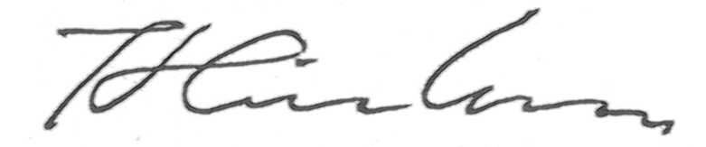
J.Hindse
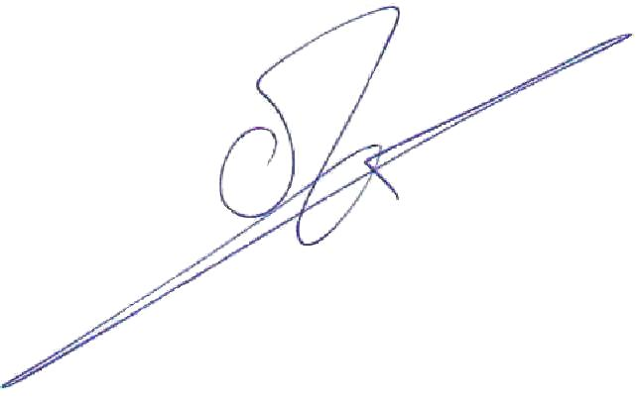
G.Jipping

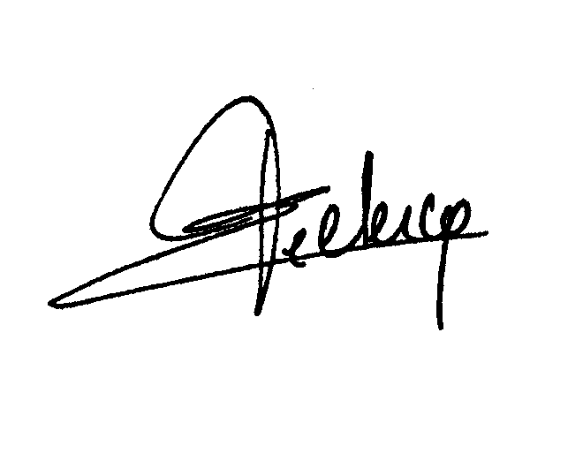
Y.De Clercq

